[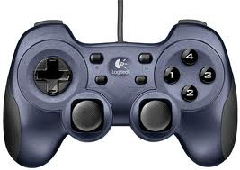](http://www.google.com/imgres?start=128&safe=active&sa=X&biw=1366&bih=648&tbm=isch&tbnid=Hot3vYjRFo32aM:&imgrefurl=http://forums.nba-live.com/viewtopic.php?f%3D124%26t%3D69490&docid=72fMauKUOp36BM&imgurl=http://www.nextway.ch/images/log_rumblepad2.jpg&w=500&h=354&ei=BvADU__EOZGBogSru4DADA&zoom=1&ved=0CGsQhBwwIjhk&iact=rc&dur=696&page=7&ndsp=21)

Arm Down

Arm Up

Button 2: Shift Gear

Left/Right

Forward/Back

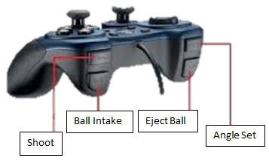

**Angle Set: 0 or 60**